# Docker for Java and Spring Boot developers

Github: <https://github.com/PacktPublishing/Docker-for-Java-and-Spring-Boot-Developers>

## AWS account

“free aws tier”

[https://aws.amazon.com/it/free/?all-free-tier.sort-by=item.additionalFields.SortRank&all-free-tier.sort-order=asc&awsf.Free%20Tier%20Types=*all&awsf.Free%20Tier%20Categories=*all](https://aws.amazon.com/it/free/?all-free-tier.sort-by=item.additionalFields.SortRank&all-free-tier.sort-order=asc&awsf.Free%20Tier%20Types=*all&awsf.Free%20Tier%20Categories=*all)

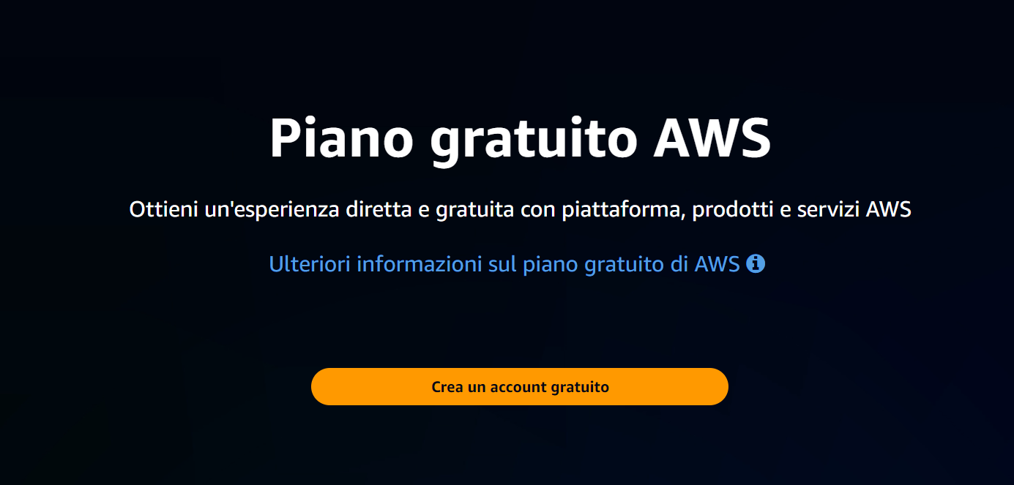

## EC2 Elastic Compute Cloud

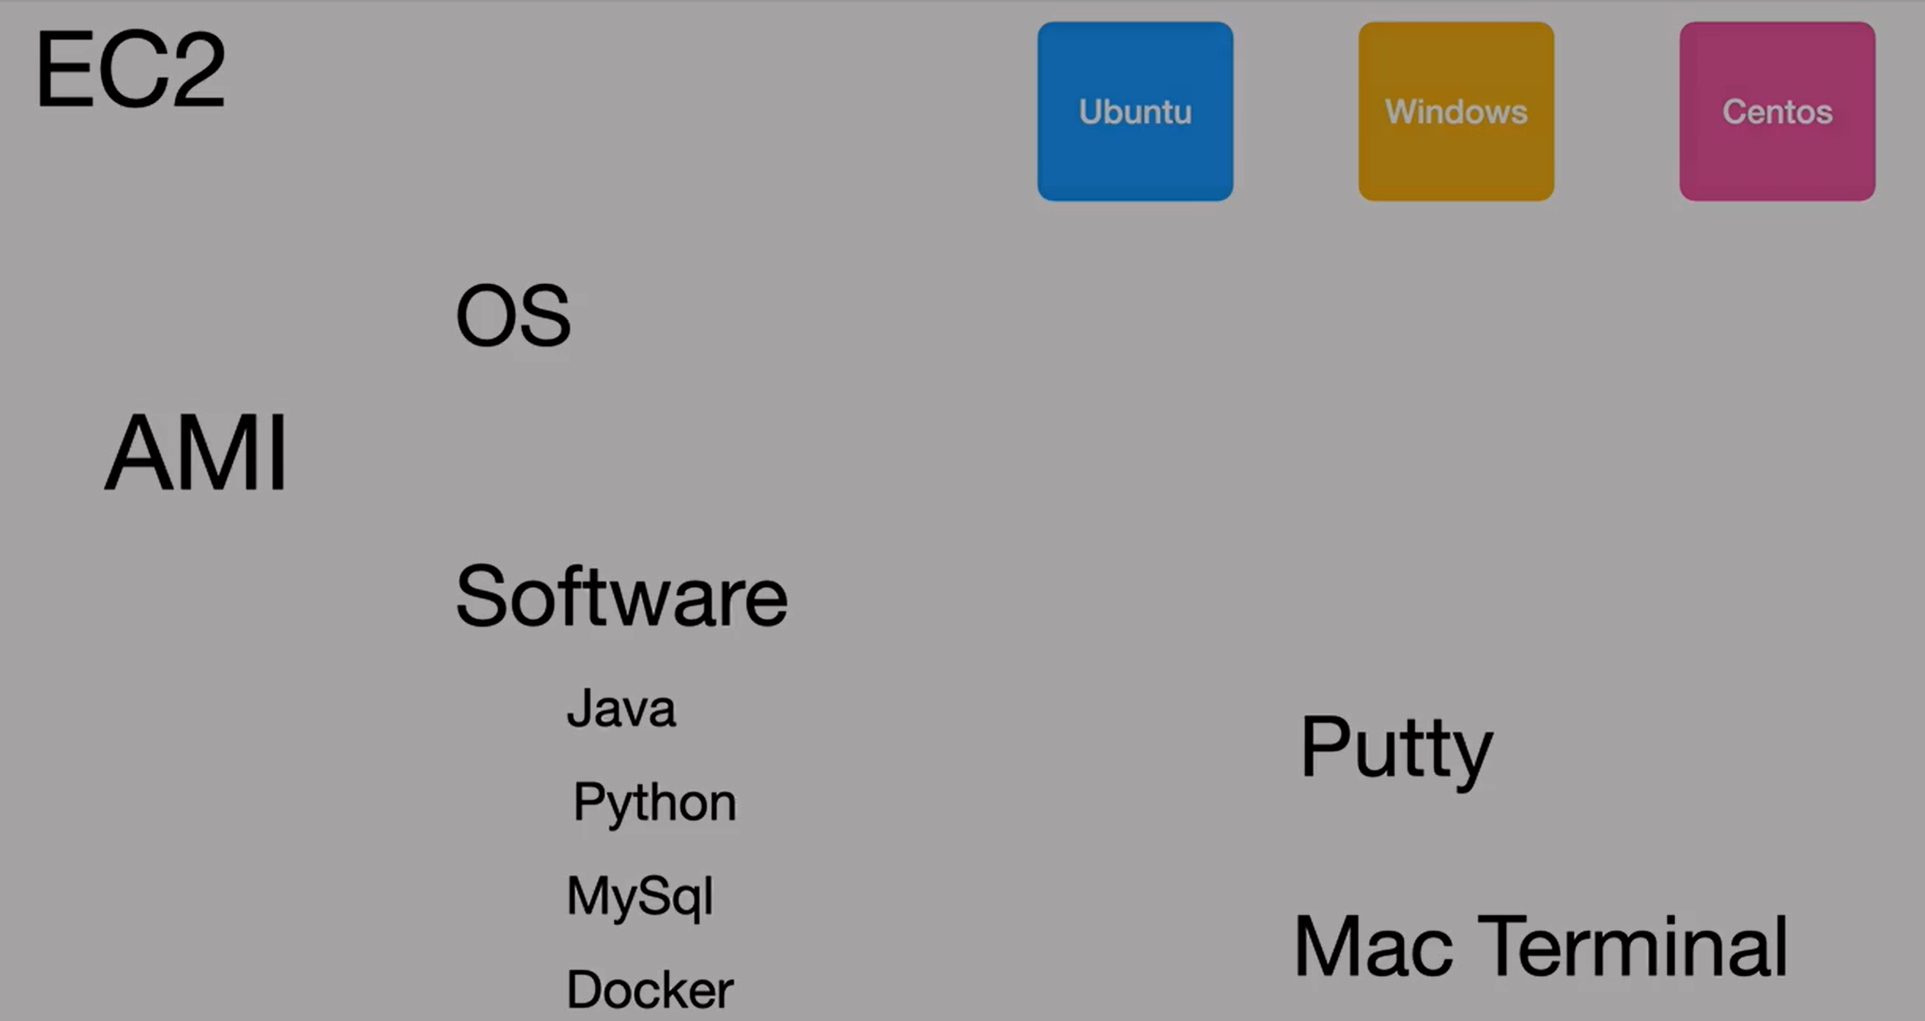

**AMI** stands for **Amazon Machine Image**.

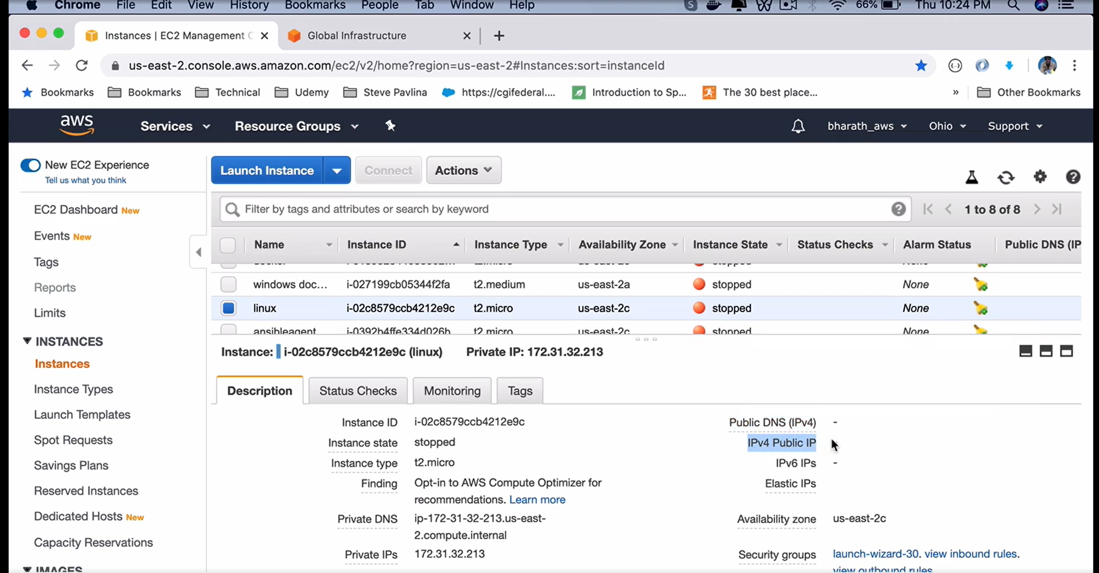

## Linux

### Checking resources

**top**

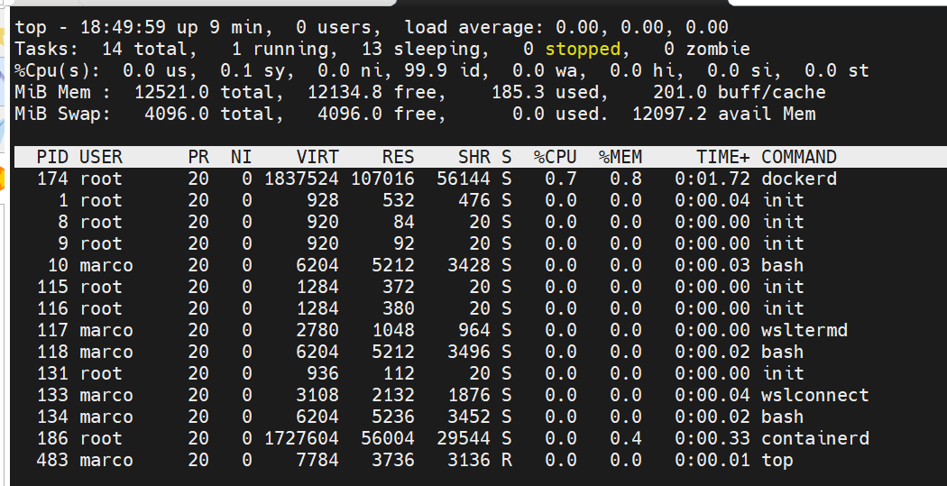

### ls /

1. **ls /** shows folders in root folder
2. **ls /bin**  in /bin all command line are stored
3. **ls /etc**  in /etc all configuration files are stored
4. **ls /dev** /dev is the folder in which all hardware devices are mapped
5. **ls /home** /home contains users
6. **ls /lib** /libraries kernel and programs
7. **ls /mnt** /mnt contains the removable mounted devices
8. **ls /opt** /opt contains application binaries
9. **ls /proc** kernel related processes
10. **ls /root** home directory of root user
11. **ls /sbin** system administration commands
12. **ls /tmp** temporary directory
13. **ls /usr** all small programs accessible from users and some command line administration tools
14. **ls /var** variables data

## SSH

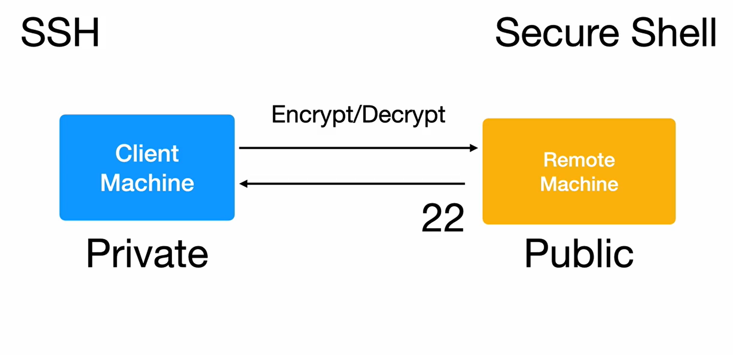

## Vi

**i** – insert mode

**ESC** – to pass to command mode

In command mode – **SHIFT – $** goes to the end of the line

In command mode – **SHIFT – ^** goes to the beginning of the line

In command mode – **o** – inserts a new line

In command mode – **dd**  - removes a line

In command mode – **2dd**  - removes two lines

In command mode – **yy** – copies a line

In command mode – **p** – paste a line copied with **yy**

In command mode – **ESC :/ STRING-TO SEARCH** – searches a string

## Usecase

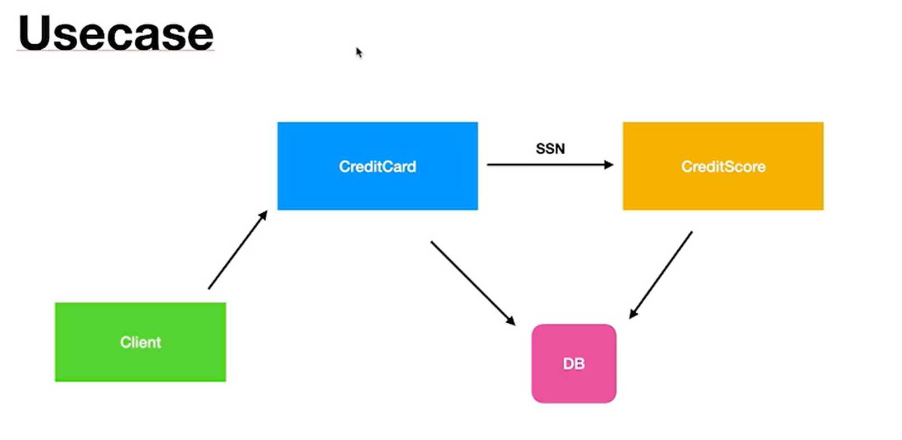

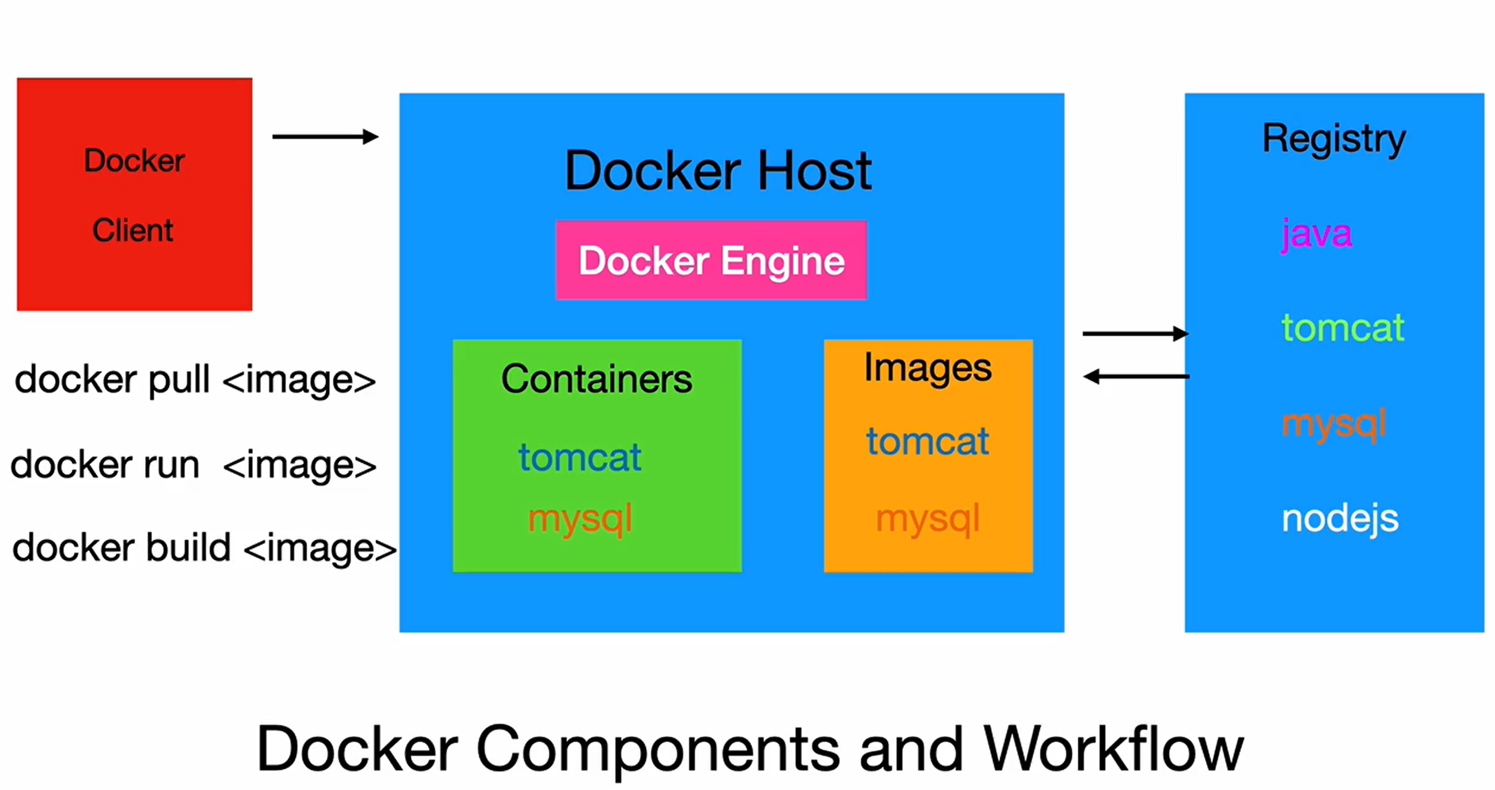

## Build a Dockerfile

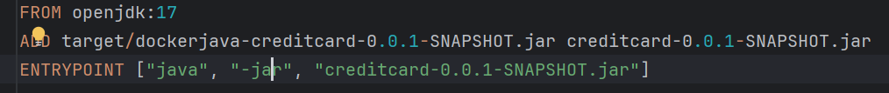

**docker build -f Dockerfile -t creditscore-app** .

The --link flag in Docker was previously used to **establish a connection** between different containers. It essentially created a **symbolic link** between the source container (the one providing the service) and the target container (the one needing the service). This allowed the target container to access the source container using a specific alias, simplifying communication.  
In **--link mysql-db:mysql**  mysql  is the alias of mysql-db

**docker run -t --name=crediscore-app --link mysql-db:mysql -p 10555:8080 creditscore-app**

## Docker compose

**docker-compose.yaml**  is used to define services that compose an application.

**docker compose up** (searches for docker-compose.yaml)

or

**docker compose up -f docker-compose.yaml**

## Yaml

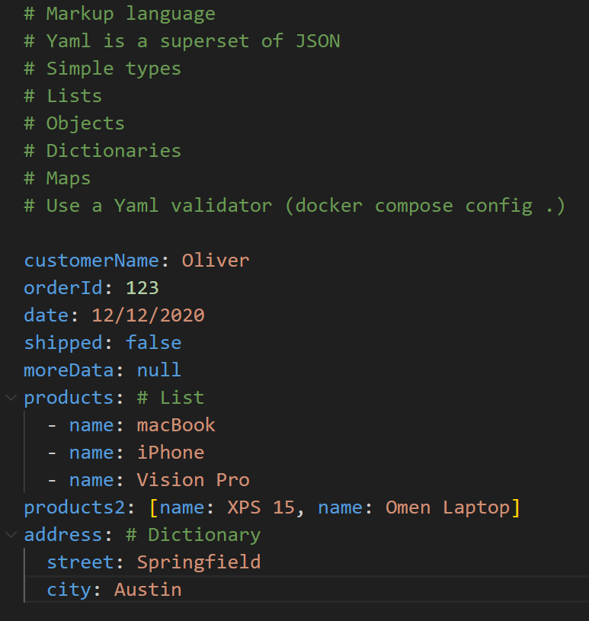

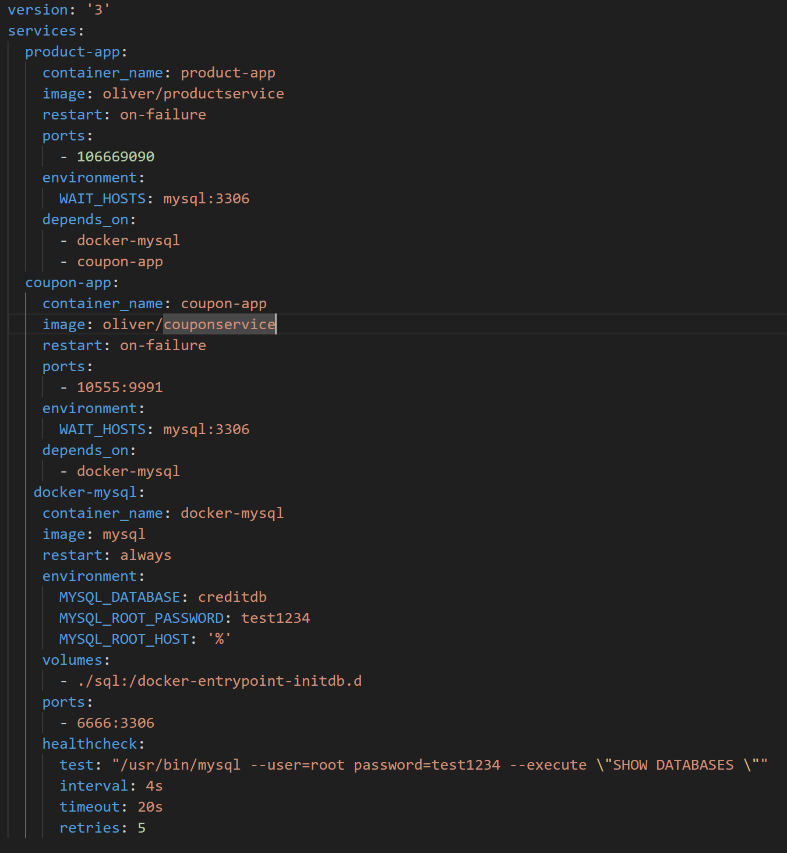

### Networks

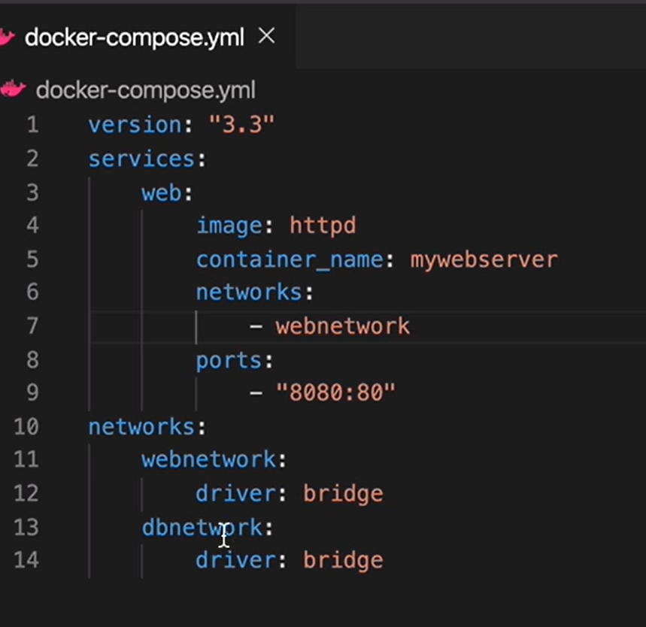

### Volumes

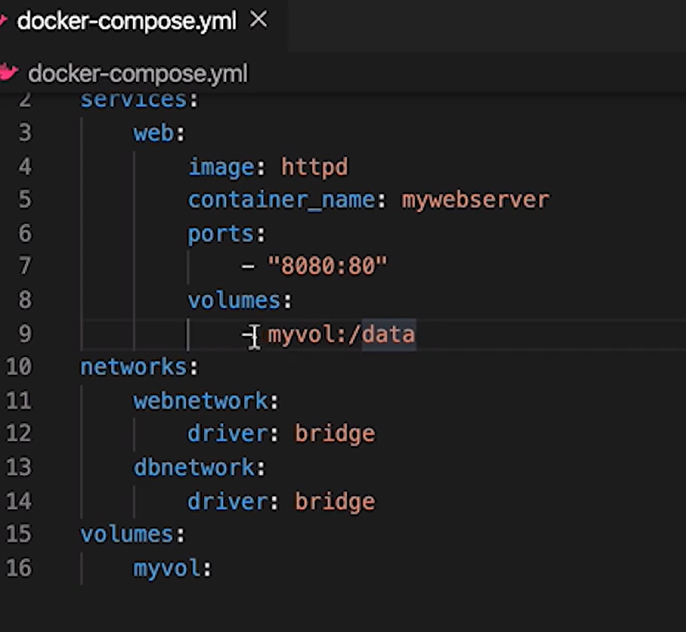

## Docker Swarm

Docker Swarm is an orchestration tool.

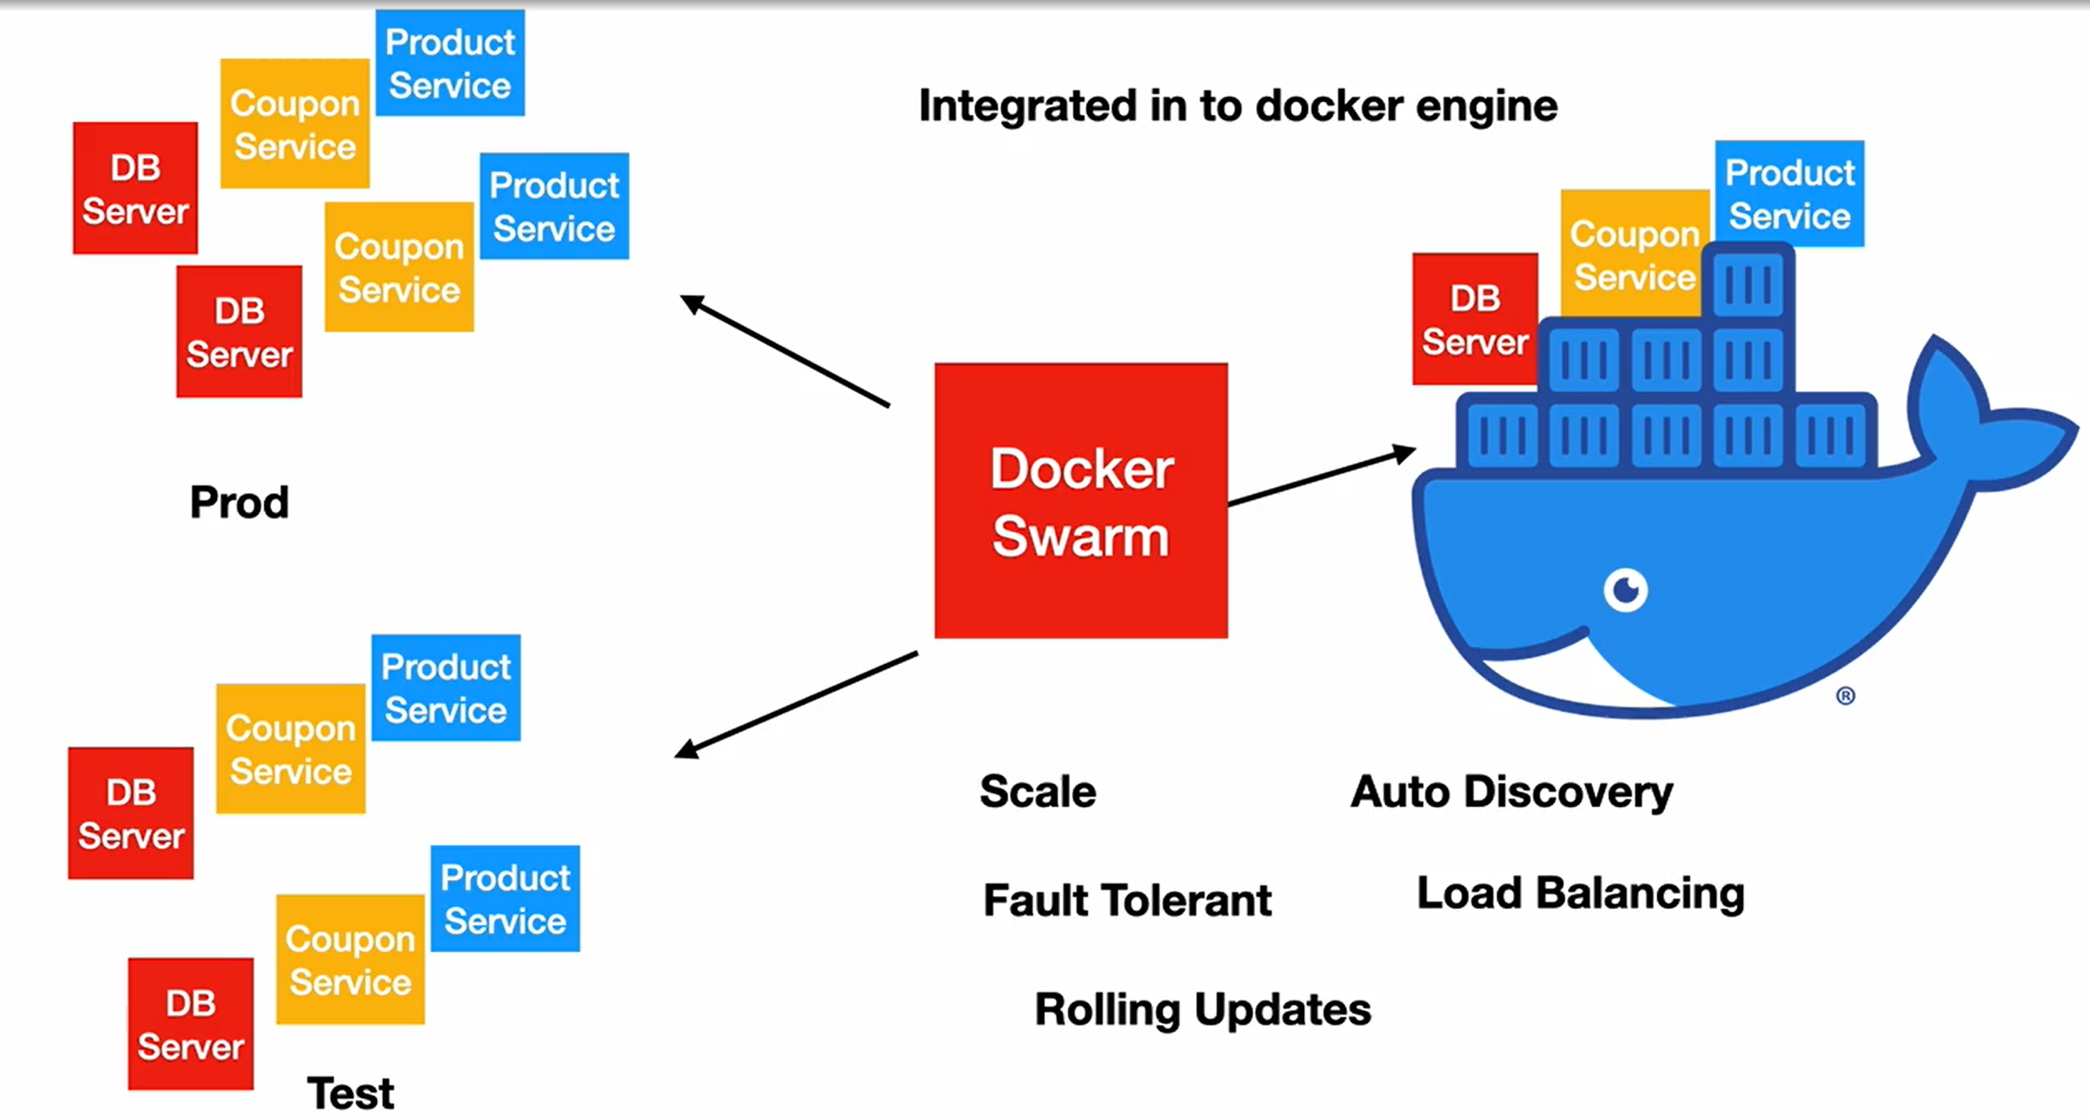

### Pods

A pod is a **group of one or more tightly coupled containers** that share storage (volumes) and network resources.

### docker swarm init

docker swarm init

* creates a manger node
* creates TLS certificates and token used by manager and workers nodes

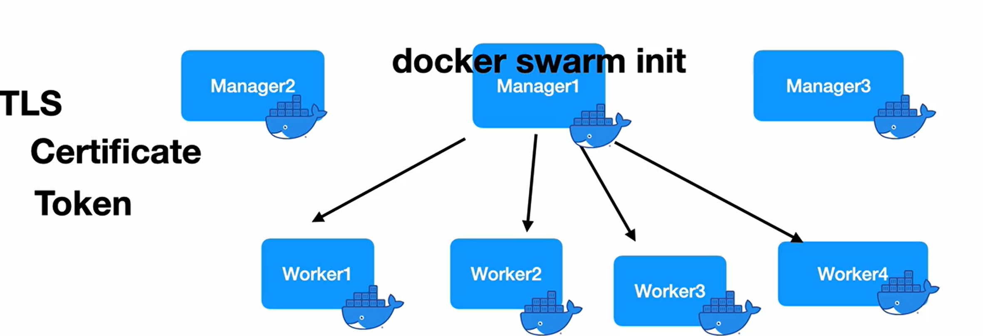

### Service

* A service is essentially a template that specifies how containers should be created and configured
* It defines details such as:
  + Image: The container image to use for running the service.
  + Command: The command to execute within the containers.
  + Networking: How the containers should be connected within the swarm network and potentially exposed externally.
  + Restart policy: How to handle container failures and restarts.
  + Resource constraints: Resource limitations for CPU, memory, and other resources.

### Task

* It is the running instance of a container created based on the service definition.

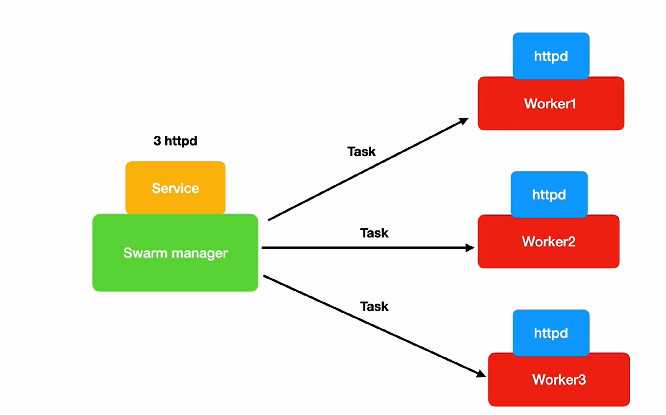

### Swarm architecture

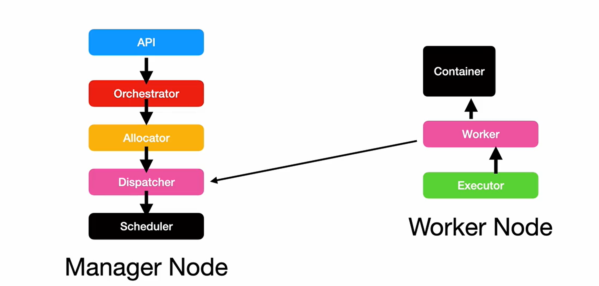

### Set up Swarm

docker swarm init

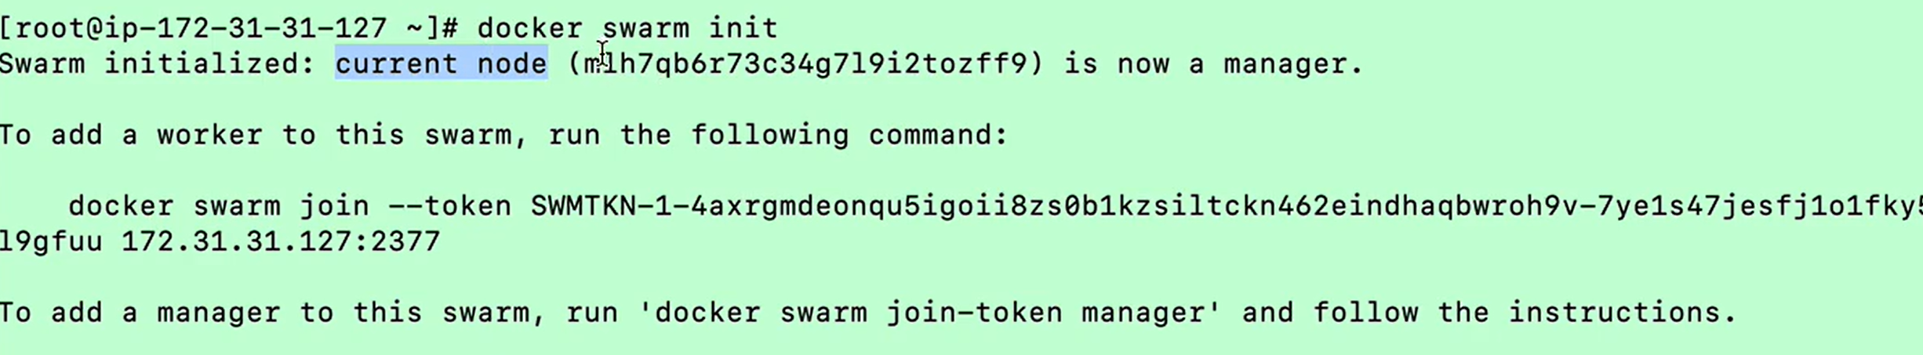

docker node ls

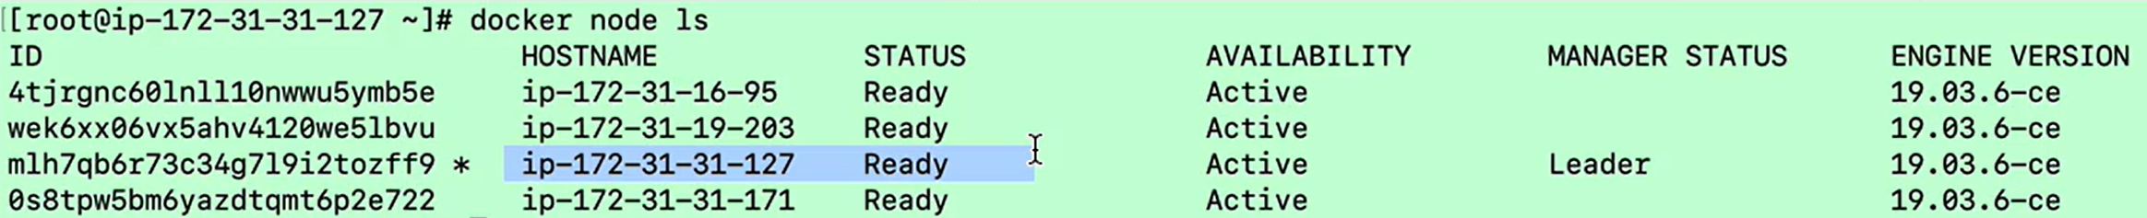

### Adding a new manager

This command must be executed from manager node.

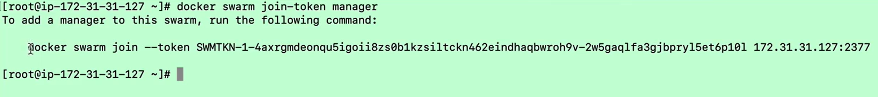

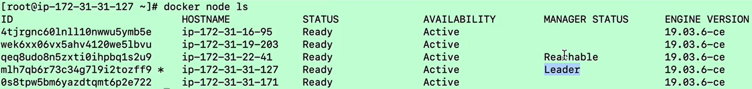

### Creating a service

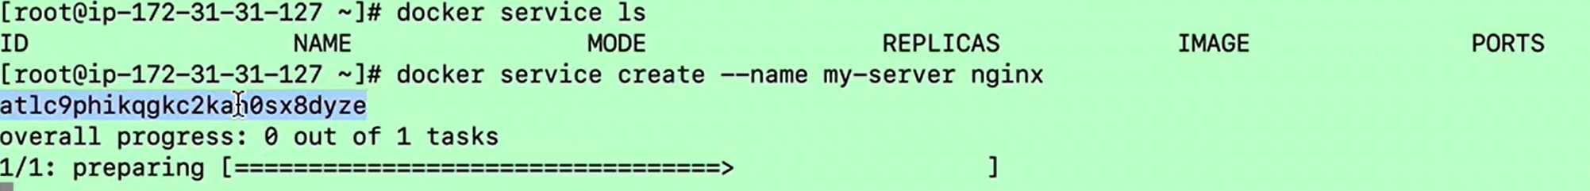

### Multiple replicas and scaling



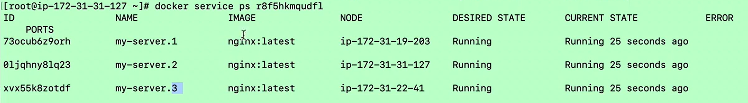





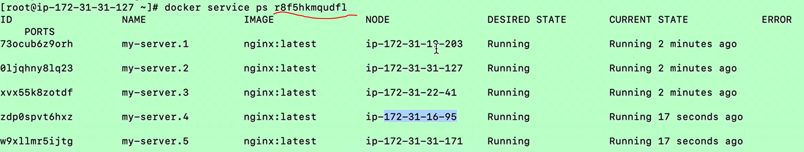

### Update and rollback





### Drain worker node

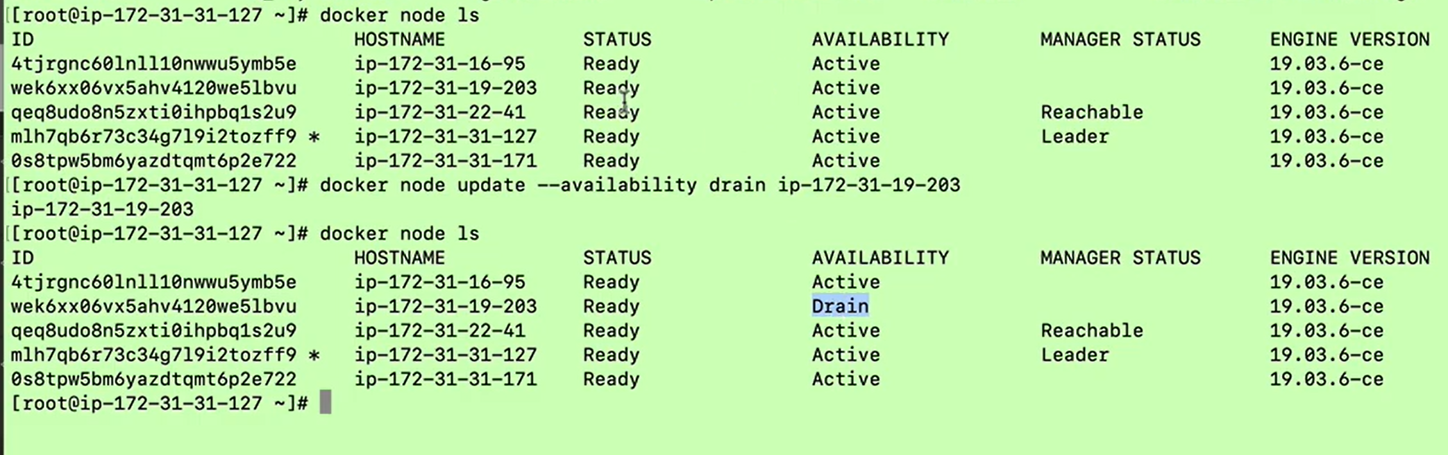

### Docker stack deploy

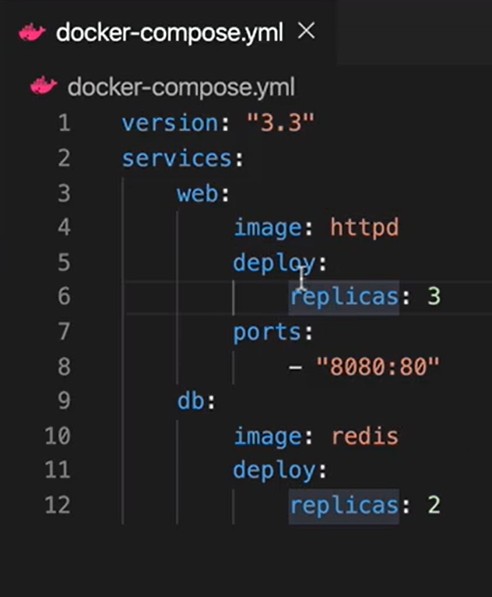

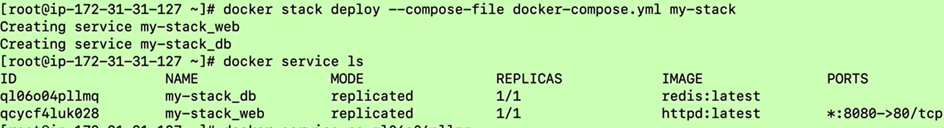

### Remove worker node



### Switching managers

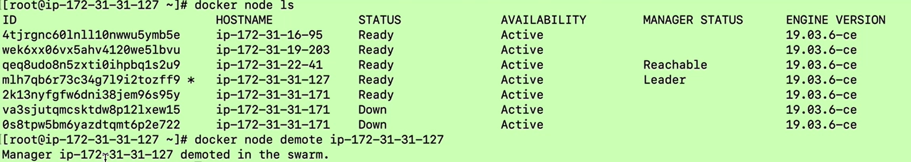

### Replicas in the Swarm

